3350 Assignment 2 – Joshua Fraser
1st Task:
Evidence on the Stability of the Phillips Curve Relationship
I investigate whether the Phillips curve relationship holds as a stable long-run relationship between inflation (Dp) and unemployment (u).
π_t=β_0+β_1 u_t+η_t,η_t∼I(0)," " β_1<0
For inflation (Dp), the Augmented Dickey-Fuller (ADF) tests reject the null of a unit root across most specifications; With drift: p-values = 0.01 across all lags and with trend: mostly significant (p ≈ 0.01–0.07). Therefore, inflation (Dp) is stationary, i.e. Dp∼I(0). For unemployment (u). ADF results show: Type 1: p-values 0.12–0.37, Type 2: p-values 0.17–0.75 and Type 3: mostly insignificant (0.07–0.46). Therefore, unemployment is non-stationary, i.e. u∼I(1).
Since the variables are mixed order of integration, this justifies the use of an ARDL bounds testing approach. Using R studio testing, the best model is found to be: ARDL(6,8) with an of AIC: 337.60 (lowest among candidates) and BIC also competitive (390.50). The lag limit was set to (8,8) as any lower would result in ARDL models that would fail the Ljung box test.
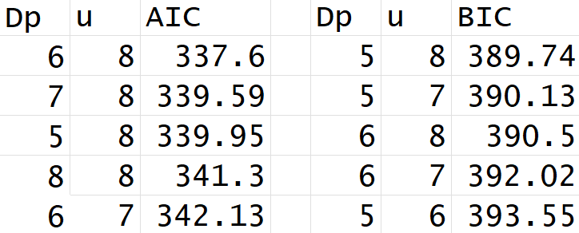
The model includes lag dynamics in both inflation and unemployment, indicating persistence in inflation and distributed lag effects of unemployment on inflation. This suggests the Phillips curve is dynamic.
For the bounds, using ARDL(6,8) model, the F-test; F-statistic = 3.2148 and p-value = 0.2846 which falls above the .05 rejection for the null hypothesis. We fail to reject the null of no cointegration and there is no evidence of a stable long-run equilibrium relationship between inflation and unemployment.
Since the ARDL bounds F-test fails to reject the null of no cointegration (F = 3.2148, p = 0.2846), there is no evidence of a stable long-run equilibrium between inflation and unemployment. Since cointegration is not supported, the long-run error correction interpretation is not valid and therefore inapplicable.
All diagnostics indicate a statistically valid short-run model. Ljung-Box test (p = 0.1516) indicts we do not reject the null hypothesis for no autocorrelation. Breusch-Pagan (p = 0.4978) also indicts we do not reject the null hypothesis for homoscedastic residuals. The residual ACF and PACF show no major structural issues.
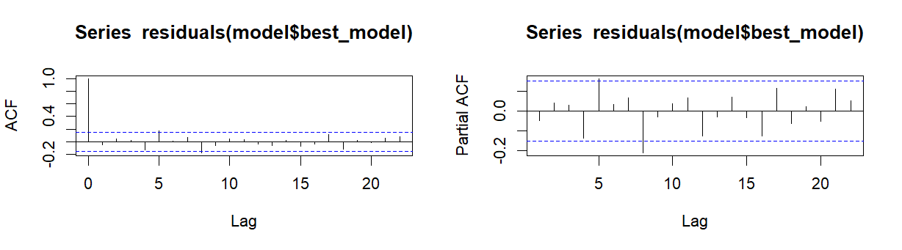
The residuals behave like white noise, therefore there is no autocorrelation structure left unexplained by the model. The model is well specified, so conclusions are presumably reliable.
From ARDL estimates immediate unemployment coefficient: u_t = -0.917
This is negative (consistent with Phillip’s curve theory) but not stable across lags (many lag coefficients alternate in sign), this suggests short-run trade-offs exist but are unstable over time.
Variable | Estimate | Std. Error | t value | Pr(>|t|) | Significance
Signif. codes: 0 ‘***’ 0.001 ‘**’ 0.01 ‘*’ 0.05
(Intercept) | 0.14166 | 0.20096 | 0.705 | 0.48194
L(Dp, 1) | 1.12392 | 0.07958 | 14.123 | < 2e-16 | ***
L(Dp, 2) | -0.02128 | 0.10882 | -0.196 | 0.84524
L(Dp, 3) | -0.13334 | 0.10135 | -1.316 | 0.19033
L(Dp, 4) | -0.42940 | 0.09874 | -4.349 | 2.51e-05 | ***
L(Dp, 5) | 0.54055 | 0.10344 | 5.226 | 5.71e-07 | ***
L(Dp, 6) | -0.14325 | 0.07176 | -1.996 | 0.04773 | *
u | -0.91687 | 0.19768 | -4.638 | 7.60e-06 | ***
L(u, 1) | 1.08613 | 0.33689 | 3.224 | 0.00155 | **
L(u, 2) | -0.10621 | 0.34517 | -0.308 | 0.75874
L(u, 3) | -0.59293 | 0.34758 | -1.706 | 0.09010
L(u, 4) | 0.76750 | 0.34642 | 2.216 | 0.02823 | *
L(u, 5) | -0.57694 | 0.34516 | -1.672 | 0.09670
L(u, 6) | -0.20829 | 0.33911 | -0.614 | 0.54001
L(u, 7) | 0.96346 | 0.33020 | 2.918 | 0.00407 | **
L(u, 8) | -0.41341 | 0.19098 | -2.165 | 0.03199 | *

There is no evidence of a stable long-run Phillips curve relationship; ARDL bounds test fails to detect cointegration (p = 0.2846), inflation is stationary while unemployment is non-stationary and a long-run equilibrium relationship is not supported. Therefore, the long-run Phillips curve is not stable in this dataset. However, in the short run, unemployment significantly affects inflation changes (strong negative coefficient), inflation is persistent (multiple significant lag terms) and the relationship is dynamic and lag dependent. This implies a short-run Phillips curve exists, but it is not stable or long-run persistent.
The empirical evidence does not support a stable long-run Phillips curve relationship between inflation and unemployment. The ARDL bounds test fails to reject the null of no cointegration, indicating the absence of a long-run equilibrium. Therefore, the relationship is best described as dynamic and short run in nature, but not stable in the long run.
2nd Task:
Although lower-order VAR specifications continued to exhibit evidence of residual autocorrelation, the Breusch Godfrey LM test results improved as the lag length increased. VAR models were estimated across lag lengths ranging from 5 to 13 using the full set of variables (Dp, u, r, twi, tot, usy) and each specification was evaluated using residual diagnostic testing, information criteria, Granger non-causality testing, and stability analysis.
Information criteria produced conflicting recommendations regarding lag selection. The AIC selected the higher-order VAR(11) specification, while the BIC favoured the lower lag models. Given the strong persistence typically present in macroeconomic time series, the higher order specification was considered more appropriate for capturing the dynamic relationships within the Australian economy. As well as this, despite high BIC values, lag length 11 were the only model/s valid for modelling as parsimony testing comes after testing for autocorrelation and heteroskedasticity.
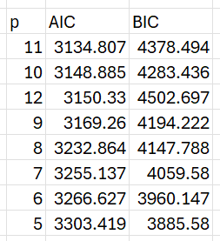
Residual diagnostic testing further supported the selection of VAR(11). Using the Breusch Godfrey LM test for first-order residual autocorrelation, the VAR(11) specification produced a p-value of 0.3839, implying failure to reject the null hypothesis of no residual autocorrelation at the 5% significance level. In contrast, higher or lower order VAR specifications continued to exhibit statistically significant serial correlation, suggesting inadequate dynamic specification.
Stability analysis also supported the selected model. The VAR(11) specification produced a maximum absolute eigenvalue of 0.974, which lies below 1.00, thus within the unit circle and therefore satisfies the VAR stability condition. This indicates that the estimated process is dynamically stable and that shocks dissipate over time. However, the eigenvalue’s proximity to unity suggests a highly persistent macroeconomic system in which adjustment to shocks occurs relatively slowly.
VAR Model | Maximum Absolute Eigenvalue
VAR(2) | 0.986
VAR(3) | 0.988
VAR(4) | 0.988
VAR(5) | 0.986
VAR(6) | 0.987
VAR(7) | 0.989
VAR(8) | 0.988
VAR(9) | 0.985
VAR(10) | 0.984
VAR(11) | 0.974
VAR(12) | 0.977
VAR(13) | 0.968

Granger non-causality testing was also used to assess whether the variables contained useful information for forecasting inflation (Dp). The results indicated that unemployment (u), the trade-weighted index (twi), and US GDP growth (usy) contributed statistically significant predictive information within the system, suggesting relevance for inflation dynamics through domestic labour market conditions, exchange rate movements, and global economic activity. In contrast, the interest rate (r) and inflation itself (Dp) showed non-statistically significant evidence of incremental predictive contribution, while the terms of trade variable (tot) exhibited no predictive content conditional on the remaining variables.
H0 (X does not Granger-cause all others)
Variable | F-Statistic | df1 | df2 | p-value | Reject H0 (5%)
Dp (Inflation) | 1.2569 | 55 | 576 | 0.1083 | No
u (Unemployment) | 1.6996 | 55 | 576 | 0.0018 | Yes
r (Interest Rate) | 1.2322 | 55 | 576 | 0.1292 | No
twi (Trade-Weighted Index) | 1.4487 | 55 | 576 | 0.0224 | Yes
tot (Terms of Trade) | 0.6686 | 55 | 576 | 0.9680 | No
usy (US GDP Growth) | 1.5136 | 55 | 576 | 0.0122 | Yes

Despite the adequacy of the selected specification, many limitations remain. The high lag order required to adequately model the Australian economy greatly increases the number of estimated parameters, potentially reducing estimation efficiency and increasing the risk of overfitting. In addition, lack of evidence of predictive contribution was observed for some variables in the Granger causality testing, suggesting that not all variables contribute significantly to forecasting performance. Furthermore, the model may still suffer from omitted variable bias due to the exclusion of potentially important macroeconomic variables.
Several additional variables could potentially improve the specification of the model. Commodity prices would be highly relevant for the Australian economy due to Australia’s dependence on exports and exposure to global supply-side shocks (Cunningham & Smith, 2019). Similarly, Chinese GDP could provide additional explanatory power given the importance of Chinese demand for Australian exports. Domestic variables such as wage growth or the output gap may also improve the modelling of inflation persistence and business cycle dynamics. Including such variables may help capture additional macroeconomic variables currently omitted from the VAR system and may improve the dynamic specification of the VAR model.
3rd Task:
The selected lag specification for the model was a VECM 11. The lag length of 11 was chosen because lower-order VAR and VECM specifications exhibited significant residual serial correlation in the Breusch–Godfrey LM tests. In contrast, only the VECM and VAR models with 11 lag specification did not reject the null hypothesis of no serial correlation.
Lag Length | r Value | Chi-Squared | p-value
2 | 0 | 78.361 | 5.616e-05
2 | 3 | 63.849 | 0.002875
2 | 4 | 63.704 | 0.00298
2 | 5 | 63.813 | 0.0029
2 | 6 | 63.828 | 0.00289
10 | 6 | 67.309 | 0.001193
11 | 4 | 36.915 | 0.4264
11 | 5 | 38.028 | 0.3771
11 | 6 | 37.872 | 0.3839
13 | 6 | 90.140 | 1.544e-06

The VECM(11,4) specification is selected as the preferred model based on a combination of cointegration rank determination and AIC/BIC testing. The Johansen cointegration results indicate that four cointegrating relationships are supported by the data, as additional cointegrating vectors beyond r = 4 lead to weaker identification and less stable long-run models, suggesting potential over-parameterisation. Since the system contains six endogenous variables, the cointegration rank can be at most k − 1 = 5, rendering the VECM(11,6) specification invalid. As well as this, VECM(11,4) has a good balance between non-over-parameterisation and parsimony, having the 3rd best AIC value among other lag 11 VECM models.
p | r | aic | bic
11 | 6 | 3134.807 | 4378.494
11 | 5 | 3139.975 | 4383.663
13 | 6 | 3146.471 | 4607.057
10 | 6 | 3148.885 | 4283.436
11 | 4 | 3149.073 | 4392.761
12 | 6 | 3150.330 | 4502.697
13 | 5 | 3152.507 | 4613.093
10 | 5 | 3152.700 | 4287.251
12 | 5 | 3157.219 | 4509.586
13 | 4 | 3162.205 | 4622.790

Among the lag specifications that pass diagnostic testing, VECM(11,4) is still preferred due to its parsimony relative to higher r models with the same lag length, while still maintaining a well-defined cointegration structure.
The ordering of variables used for the Cholesky decomposition are as follows:
(usy, tot, twi, r, Dp, u)
This ordering reflects the assumption that foreign and external variables simultaneously affect the Australian economy, while Australian domestic variables do not immediately influence foreign conditions within the same quarter. The US variable ‘usy’ was placed first as it is practically exogenous to Australia. The terms-of-trade ‘tot’ was ordered second because commodity prices and export demand are determined largely internationally. The trade-weighted index ‘twi’ was placed next as exchange rates respond quickly to external and financial market conditions. The domestic interest rate ‘r’ was then ordered before inflation and unemployment because monetary policy decisions may react at the same time as external developments, while inflation and labour market conditions typically adjust more gradually. Inflation ‘Dp’ was placed ahead of unemployment ‘u’, reflecting the relatively slow adjustment of labour market conditions.
Response to a Terms-of-Trade Shock
The inflation response to a positive terms-of-trade shock is statistically insignificant across the entire eight-quarter horizon, as the 95% bootstrap confidence intervals contain zero throughout. The point estimate of the impulse response dips somewhat negative between quarters two and five before gradually returning toward zero and slightly above it, suggesting that if anything, a positive terms-of-trade shock places modest downward pressure on domestic inflation in the short to medium run.
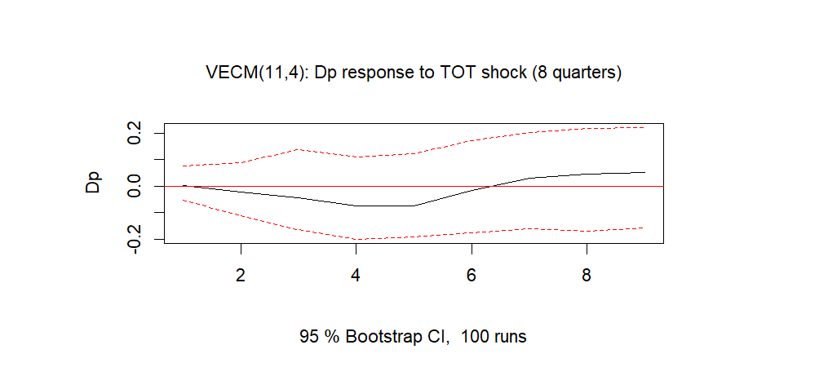
This could plausibly reflect exchange rate appreciation accompanying the terms-of-trade improvement, which would lower the domestic price of imported goods and offset demand-side inflationary pressures. However, given that the confidence bands are wide and consistently include zero, no strong conclusions can be drawn about the direction or magnitude of the inflation response. The data therefore do not support the view that a positive terms-of-trade shock generates upward pressure on Australian domestic prices over an eight-quarter horizon within this model.
The unemployment response to a positive terms-of-trade shock shows a persistent negative point estimate throughout the eight-quarter horizon, declining to approximately −0.1 by quarter eight. This is consistent with the view that improved export revenues and stronger economic activity raise labour demand and reduce unemployment. Notably, the effect does not diminish over the horizon, if anything, it deepens gradually, suggesting the labour market response may be slow-building and persistent. However, the 95% bootstrap confidence bands contain zero across most of the horizon, meaning the result falls short of conventional statistical significance and should be interpreted cautiously.
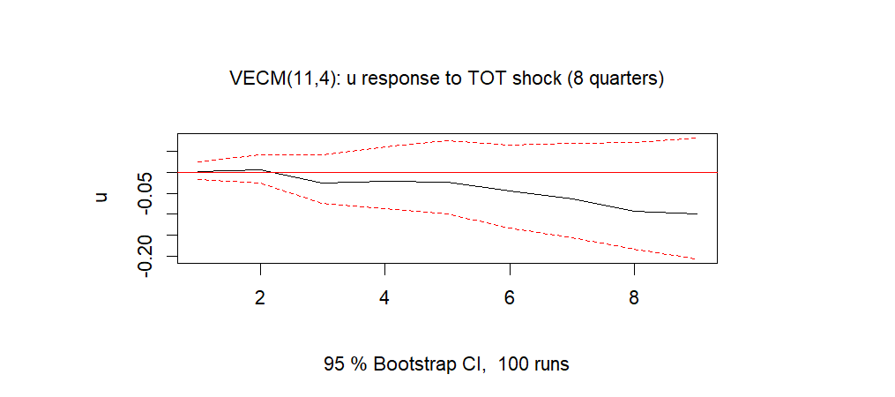
Overall, while the impulse responses point towards an economic conclusion, with external conditions associated with lower unemployment, neither the unemployment nor the inflation responses are statistically distinguishable from zero within this model.
Response to a Domestic Monetary Policy Shock:
The impulse response function shows that Australian inflation responds positively to a positive 0.5 percentage point shock to the domestic interest rate, rising gradually from near zero at impact and peaking around quarter 5, before partially declining toward the end of the two-year horizon. This is contrary to standard macroeconomic expectations, where a tightening of monetary policy would typically dampen inflationary pressures by reducing aggregate demand.
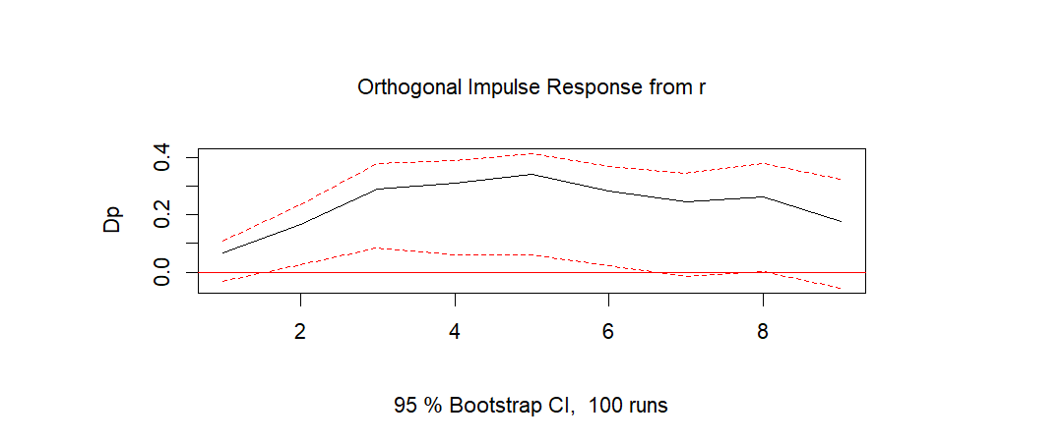
The result is statistically significant, as the lower confidence band dips above zero across much of the horizon. Therefore, the point estimate suggests a positive relationship, this can be distinguished from zero with confidence, and a reliable conclusion about the effect of monetary policy on Australian inflation can be drawn from this model over the two-year period.
The impulse response function shows that unemployment responds negatively to a positive 0.5 percentage point shock to the domestic interest rate, declining steadily from near zero at impact and troughing at approximately −0.15 around quarter 5, before gradually recovering toward −0.10 by quarter 8. This is again contrary to standard macroeconomic expectations, where a tightening of monetary policy would typically raise unemployment by cooling economic activity and reducing labour demand.
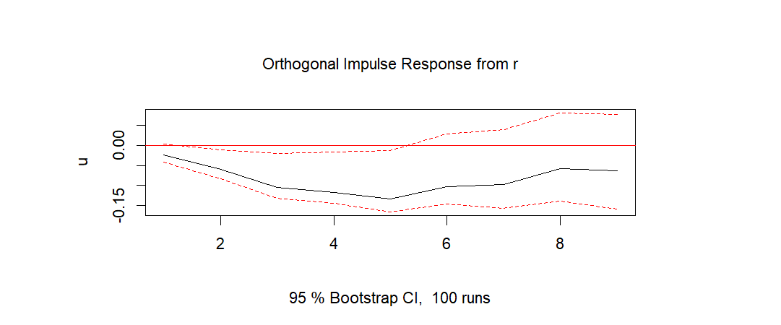
However, the result is statistically significant for the first half of the horizon, as the upper confidence band remains below zero throughout. Therefore, the point estimate suggests a negative relationship and can be distinguished from zero with confidence, and conclusions about the effect of monetary policy on Australian unemployment can be drawn from this model over the first half of the two-year period.
4th Task:
Here is the forecast using the holdout sample 4 quarters into the future represented by a blue dotted line with the preferred VAR/VECM model (11,4) as well as a 95% CI represented by the red dotted line.
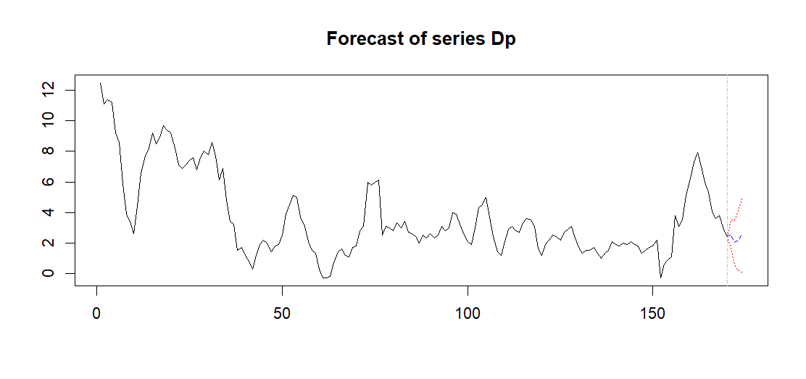
The widening confidence intervals across the forecast horizon indicate widening uncertainty in the VAR predictions as the forecast extends further into the future.
Using root mean squared errors (RMSE) and mean absolute errors (MAE), the comparison between the consumer and economist expectations as well as the VAR model forecast to the actual inflation during the 4 quarters of 2025 are as follows:
Model | RMSE | MAE
VAR | 0.777 | 0.601
Consumers | 1.668 | 1.532
Economists | 0.797 | 0.750

The VAR model produces the most accurate inflation forecasts over the 2025 4 quarter period, achieving the lowest RMSE (0.777) and MAE (0.601) of the three approaches. The economists' forecasts perform similarly, with only slightly higher RMSE (0.797) and MAE (0.750), suggesting that economist forecasters and the VAR based approach capture similar inflation dynamics over this period. Consumer expectations perform worse on both metrics, with RMSE (1.668) and MAE (1.533) roughly double that of the VAR and economists, indicating that consumers misjudge the inflation outlook over 2025.
Quarter | VAR Forecast | Consumers | Economists
2025Q1 | 2.562 | 4.35 | 3.20
2025Q2 | 2.043 | 4.43 | 3.10
2025Q3 | 2.124 | 4.43 | 2.90
2025Q4 | 2.491 | 4.22 | 2.70

Given that Australian inflation was elevated in 2022–2023 before declining, consumers may have been slow to change their expectations downward, leading to persistent over-prediction of inflation.The economists’ forecasts performed similarly to the VAR forecasts, suggesting that both approaches captured the deflation trend during 2025 reasonably well.

References:
Cunningham, M., & Smith, E. (2019). Exploring the Supply and Demand Drivers of Commodity Prices. https://www.rba.gov.au/publications/bulletin/2019/jun/pdf/exploring-the-supply-and-demand-drivers-of-commodity-prices.pdf

